**UML 2.5 NOTATION RULES FOR DRAWING Use Case DIAGRAMS**

**SYSTEMS ANALYSIS DIAGRAMS**

The UML notation is rich and full bodied. It is comprised of two major subdivisions.

* **There is a notation for modelling the static elements of a design such as classes, attributes, and relationships.**
* There is also a notation for modelling the dynamic elements of a design such as objects, messages and finite state machines.

**USE CASE DIAGRAMS**

|  |  |  |
| --- | --- | --- |
| **COMPONENT** | **RULES** | **EXAMPLE** |
| **Boundary Box** | https://www.visual-paradigm.com/VPGallery/img/usecase/SystemBoundary/System-Boundary-Sample.png | * Draw your system's boundaries using a rectangle that contains use cases. Place actors outside the system's boundaries * Name the boundary box e.g. Library System (first letter upper case) |
| **Actor** | Use case actor as stick man. | * Standard UML icon for actor is "stick man" icon with the name of the actor above or below the icon. * Actor names – first letter of word is upper case, all other letters lower case * All actors must have a name |
| **Generalization (Inheritance) between actors** | Generalization between use case actors. | * Generalization between actors is rendered as a solid directed line with a large arrowhead |
| **Use Case** |  | * Every use case must have a name. * Use case is shown as an ellipse containing the name of the use case * First word should be a verb and 2or 3 more words max * First letter is upper case * Second word can start with first letter upper or lower case . * Must keep consistency across all use cases in the diagram |
| **Communication Association** | An actor could be associated to one or several use cases. | * An actor must be associated with at least one use case. * An actor can be associated with multiple use cases. * Multiple actors can be associated with a single use case. * An association is a line drawn from the actor to the use case |

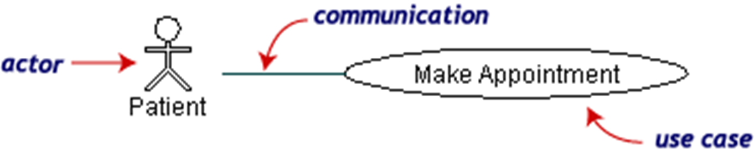

**TIPS TO CREATE A PROFESSIONAL USE CASE DIAGRAM**

|  |  |
| --- | --- |
| **1** | Think from end user’s perspective |
| **2** | Avoid long use case name |
| **3** | Actor is a role, not a real person |
| **4** | Apply same width on use cases when appropriate |
| **5** | Position actors and use cases in a meaningful way |